- Disconnect and isolate the negative battery cable.
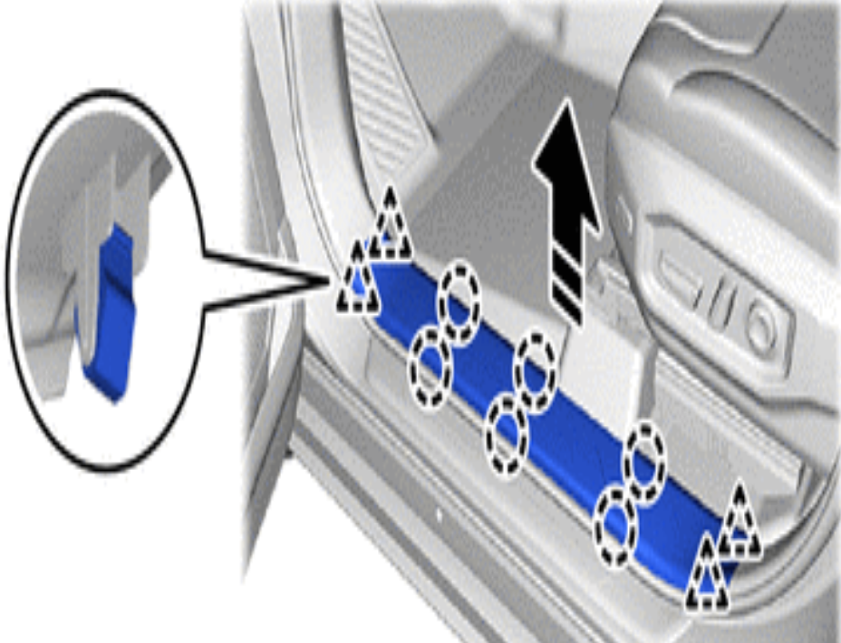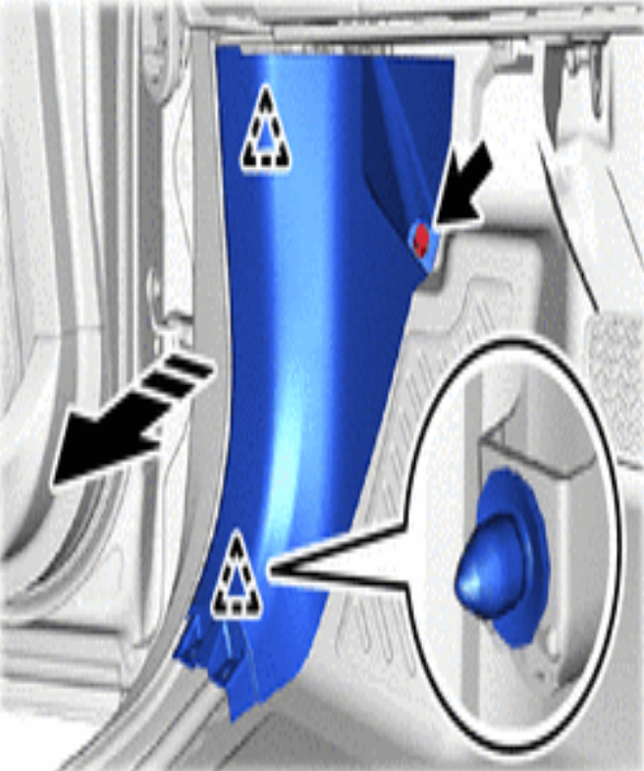
- Remove the Front Door Scuff Plate and the Cowl Side Trim.
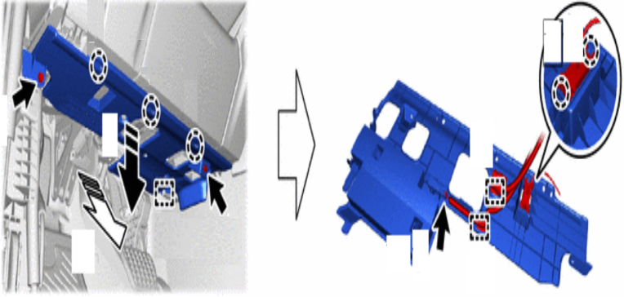
- Remove the Intrument Panel Under Cover.
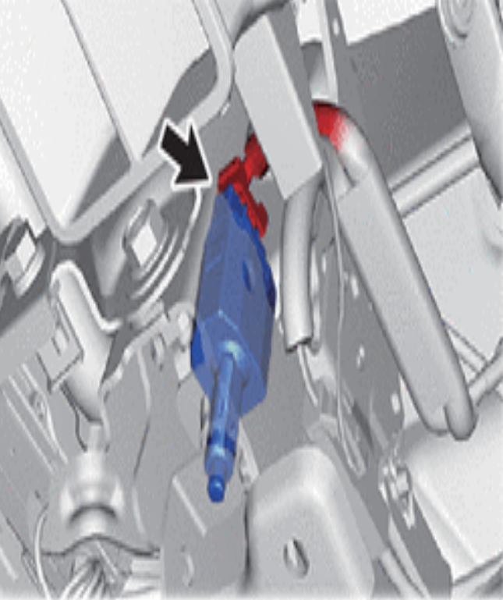
- Locate the OEM Stop Lamp Switch and disconnect the connector (red).
- Plug one side of the 007-234 T-Harness into the OEM connector and the other side into the OEM Stop Lamp Switch.
- Route the rest of the harness through a drain plug in the floor, to the back of the vehicle, and plug it into the aftermarket 3rd brake light.
- Follow steps 1-4 in reverse order to reinstall the removed trim panels and reconnect vehicle battery.

